**Tab 1**

## Health Insurance System

### 1. Introduction

**1.1 Purpose**

The purpose of this document is to provide a comprehensive Software Requirements Specification (SRS) for the Health Insurance System. The document will detail the functional and non-functional requirements, use cases, and other necessary specifications to guide the development of the system.

**1.2 Scope**

This Health Insurance System will allow users to register for health insurance, submit claims, pay premiums, manage policies, track claim statuses, and interact with customer support. The system will integrate with the hospital's financial system for real-time data exchange and synchronization, facilitating efficient billing and claims processing.

**1.3 Definitions, Acronyms, and Abbreviations**

* MIS: Management Information System
* FHIR: Fast Healthcare Interoperability Resources
* HL7: Health Level Seven (standard for exchange, integration, sharing, and retrieval of electronic health information)

**1.4 References**

* HL7 Standard
* FHIR Specification
* Project Documentation

**1.5 Overview**

The document is organized as follows:

* Section 1: Introduction
* Section 2: Functional Requirements
* Section 3: Non-Functional Requirements
* Section 4: Use Cases
* Section 5: Requirements Traceability Matrix (RTM)
* Section 6: Personas

### 2. Functional Requirements

#### 1. User Registration

* **FR-001**: The system shall allow users to register for health insurance online through a dedicated registration page.
* **FR-002**: The system shall prompt users to input personal information, including:
  + Name
  + Date of Birth
  + Contact Information
* **FR-002.1**: The system shall allow users to specify their preferred language or communication method during registration.
* **FR-003**: The system shall allow users to select a health insurance plan during the registration process. (HMO , PPO , EPO , POS ,..) .
* **FR-004**: The system shall enable users to upload required documents for registration.
* **FR-004.1**: The system shall provide a checklist or information guide for required documents during registration.
* **FR-005**: The system shall validate user inputs and display error messages for missing or incorrect information.
* **FR-006**: Upon successful registration, the system shall send a confirmation email to the user.

#### 2. Claim Submission

* **FR-007**: The system shall allow registered users to log in and access the claim submission section.
* **FR-008**: The system shall prompt users to enter claim details, including:
  + Date of Treatment
  + Treatment Type
  + Claim Amount
  + **The system shall synchronize claim details with the hospital financial system in real-time for payment reconciliation and reimbursement processing.**
* **FR-008.1**: The system shall allow users to save partially completed claims and return to them later.
* **FR-009**: The system shall allow users to upload relevant documents (e.g., medical bills, and receipts) during the claim submission process.
  + **The uploaded documents will be synchronized with the hospital financial system for proper billing and payment updates.**
* **FR-010**: The system shall validate the completeness and accuracy of submitted claims.
* **FR-010.1**: The system shall provide a detailed error report explaining why a claim was incomplete or inaccurate.
* **FR-011**: The system shall generate a unique claim reference number upon successful submission and notify the user via email.

#### 3. Payment Processing

* **FR-012**: The system shall allow users to log in to their accounts to pay insurance premiums.
  + **The payment details will be synchronized with the hospital financial system to ensure real-time tracking of payments and outstanding bills.**
* **FR-013**: The user interface shall display the due premium amount when accessing the payment section.
* **FR-014**: The system shall support multiple payment methods, including credit cards, debit cards, and online wallets.
  + **The payment methods will integrate with the hospital financial system to reflect the real-time payment status.**
* **FR-015**: The system shall process payments through integrated payment gateways.
  + **The payment gateway shall be integrated with the hospital financial system to reflect real-time payment statuses.**
* **FR-016**: The system shall update the payment status in the user account post-transaction and send a payment confirmation email.

#### 4. Policy Management

* **FR-017**: The system shall allow users to view their active health insurance policies once logged in.
* **FR-018**: The system shall display comprehensive policy details, including plan types, coverage, and exclusions.
  + **Policy details may reflect the real-time claims and payments data from the hospital financial system.**
* **FR-019**: The system shall allow users to download or print their policy documents.
* **FR-020**: The system shall notify users if they attempt to access an expired policy.

#### 5. Policy Renewal

* **FR-021**: The system shall identify policies nearing expiration or that have expired within a grace period.
* **FR-022**: Users shall be allowed to select and renew their expiring policies online.
* **FR-022.1**: The system shall send automated reminders to users about upcoming renewals at specified intervals (e.g., 30 days, 15 days, 1 day before expiration).
* **FR-023**: The system shall facilitate payment for policy renewals and display renewal confirmations.

#### 6. Claims Status Tracking

* **FR-024**: The system shall allow users to view the status of their submitted claims after logging in.
  + **Claim statuses shall be synchronized with the hospital financial system in real-time, showing the current status (e.g., pending, approved, rejected).**
* **FR-025**: The system shall display a list of all submitted claims and their current statuses.
* **FR-026**: The system shall notify the user if they attempt to view a non-existent claim.
* **FR-026.1**: The system shall provide a mechanism for users to appeal rejected claims directly within the system.

#### 7. Customer Support

* **FR-027**: The system shall provide an integrated help desk or support section for users to raise queries or issues.
  + **Support may include financial data and claim statuses from the hospital’s financial system.**
* **FR-028**: The system shall enable users to contact support via multiple channels, including email, chat, or a support ticketing system.
* **FR-029**: The system shall provide an FAQ section to address common user concerns.
* **FR-030**: The system shall allow users to track the status of their support tickets.

#### 8. Integration with Hospital Financial System

* **FR-031**: The system shall integrate with the hospital’s financial system to enable real-time data exchange.
* **FR-032**: The system shall ensure that the financial system provides real-time updates on payments, outstanding bills, and insurance reimbursements.
* **FR-033**: The integration shall support standardized data formats, such as HL7, FHIR, or APIs, for seamless interoperability between the health insurance system and the hospital financial system.
* **FR-034**: The system shall allow seamless data exchange between the health insurance system and the hospital financial system to ensure accurate financial reporting and transparency across departments.

### Sprint 1: Minimum Viable Product (MVP)

**Objective:** Deliver core functionalities to enable basic user operations such as registration, policy management, and basic payment processing.

#### Features in Sprint 1:

1. **User Registration**
   * FR-001: Registration through a dedicated page.
   * FR-002: Input personal information.
   * FR-002.1: Specify preferred language/method.
   * FR-003: Select a health insurance plan.
   * FR-004: Upload required documents.
   * FR-004.1: Provide a checklist for documents.
   * FR-005: Validate user inputs.
   * FR-006: Send confirmation email after successful registration.
2. **Policy Management**
   * FR-017: View active health insurance policies.
   * FR-018: Display policy details (plan type, coverage, exclusions).
3. **Payment Processing**
   * FR-012: Log in to pay insurance premiums.
   * FR-013: Display due premium amount.
   * FR-014: Support credit card and debit card payments.
   * FR-016: Update payment status post-transaction and send confirmation email.

### Sprint 2: Expanded Functionality

**Objective:** Add claim submission and tracking features along with policy renewal functionality for a more robust product.

#### Features in Sprint 2:

1. **Claim Submission**
   * FR-007: Log in to access the claim submission section.
   * FR-008: Enter claim details (date, type, amount).
   * FR-008.1: Save partially completed claims.
   * FR-009: Upload relevant documents (e.g., medical bills).
   * FR-010: Validate submitted claims.
   * FR-010.1: Provide error reports for incomplete/inaccurate claims.
   * FR-011: Generate unique claim reference number and notify via email.
2. **Policy Renewal**
   * FR-021: Identify policies nearing expiration or in grace period.
   * FR-022: Renew policies online.
   * FR-022.1: Send automated reminders for renewals (30, 15, 1 day).
   * FR-023: Facilitate renewal payments and display confirmation.
3. **Claims Status Tracking**
   * FR-024: View the status of submitted claims.
   * FR-025: Display a list of submitted claims and statuses.

### Sprint 3: Advanced Features & Integration

**Objective:** Implement advanced features like customer support, integration with the hospital financial system, and seamless claim appeals.

#### Features in Sprint 3:

1. **Claims Status Tracking (Advanced)**
   * FR-026: Notify users about non-existent claims.
   * FR-026.1: Allow users to appeal rejected claims.
2. **Customer Support**
   * FR-027: Provide an integrated help desk for queries.
   * FR-028: Enable support via email, chat, or tickets.
   * FR-029: Add an FAQ section.
   * FR-030: Track support ticket statuses.
3. **Integration with Hospital Financial System**
   * FR-031: Enable real-time data exchange with the hospital financial system.
   * FR-032: Provide real-time updates on payments, bills, and reimbursements.
   * FR-033: Support standardized data formats like HL7, FHIR, or APIs.
   * FR-034: Ensure accurate financial reporting and transparency.

### 3. Non-Functional Requirements

### 1. Performance Requirements

* Number of Concurrent Users:
  + Support up to 10,000 concurrent users, with real-time synchronization with the hospital financial system.
* Load Testing:
  + Sustain 1,500 transactions per minute during load tests without performance degradation.
* Stress Testing:
  + The system must operate at 85% capacity for 1 hour without downtime, including financial data exchanges.
* Response Time:
  + System response time must remain under 2.5 seconds for user actions, including real-time financial data synchronization.
* Throughput:
  + Achieve 600+ successful transactions per second under normal operating conditions, factoring in integration load.

### 2. Usability Requirements

* Efficiency:
  + Core tasks (e.g., registration, claim submission, payments) must be completed in under 3 minutes, including interactions with the financial system.
* Memorability:
  + Returning users should be able to re-familiarize themselves with the financial components in under 1 minute.
* Satisfaction:
  + Achieve a minimum 85% satisfaction score with seamless financial transaction handling.
* Ease of Use:
  + Ensure that the integration does not complicate navigation or accessibility for users.

### 3. Reliability Requirements

* Uptime:
  + Maintain 99.9% availability, including the financial system integration, ensuring continuous data exchange.
* Error Recovery:
  + Retry financial data exchanges (e.g., claim processing, payments) up to 3 times before notifying users of failure.

### 4. Security Requirements

* Authentication:
  + Implement two-factor authentication (2FA) for users accessing sensitive financial data (e.g., payment information, claim status).
* Encryption:
  + Use AES-256 for encrypting financial data at rest and TLS 1.3 for data in transit during integration with the hospital financial system.
* Data Breach Mitigation:
  + Detect suspicious financial activities (e.g., fraudulent claims or payments) and lock affected accounts within 5 minutes.

### 5. Dependability Requirements

* Availability:
  + Ensure that both the health insurance system and financial system integration are available with 99.9% uptime.
* Reliability:
  + Deliver 95% success rates for all transactions involving the financial system (e.g., payments, billing).
* Safety:
  + Safeguard against financial data loss using automated offsite backups for patient billing and claims information.
* Security:
  + Prevent unauthorized access to financial data using robust encryption and role-based access control.
* Resilience:
  + Impact: Implement disaster recovery mechanisms to quickly recover from any system failures related to the financial integration.
  + New Requirement: Recover the financial system integration within 4 hours (RTO) and ensure no more than 1 hour of data loss (RPO).

### 4. Use Cases

### Use Case 1: Register for Health Insurance

| Use Case ID | UC-001 |
| --- | --- |
| Use Case Name | Register for Health Insurance |
| Actors | Primary: patient  Secondary: Health Insurance System |
| Precondition | 1-The user has internet access.  2-The health insurance registration page is operational. |
| Basic Flow | 1-The user navigates to the health insurance registration page.  2-The system prompts the user to fill in personal details ( name, date of birth, contact information).  3-The user selects a plan and uploads the necessary documents.  4-The system validates the input and confirms registration. |
| Alternative Flow | Missing Information: The system notifies the user to complete all mandatory fields.  Invalid Plan Selection: The system prompts the user to choose a valid plan |
| Postcondition | The user is registered and receives a confirmation email. |

Use Case 2: Submit Health Insurance Claim

| Use Case ID | UC-002 |
| --- | --- |
| Use Case Name | Submit Health Insurance Claim |
| Actors | Primary Actor patient  Secondary Actors Claims Processor, System Administrator |
| Precondition | - the patient has an active policy.  - Incident covered under policy terms has occurred. |
| Basic Flow | . 1- The patient logs into their account and navigates to the "Submit Claim" section.  2-The system prompts the user to enter claim details (date of treatment, treatment type, amount).  3-The patient uploads relevant documents (e.g., medical bills, doctor's notes, treatment receipts).  4-The system validates the claim submission for accuracy and completeness.  5-The system generates a unique claim reference number and confirms submission to the user.  6- A patient receives an email with the claim reference number and estimated processing time. |
| Alternative Flow | - Incomplete document submission.  - Claim outside policy coverage. |
| Postcondition | Claim submitted successfully |

Use Case 3: Pay Insurance Premium

| Use Case ID | UC-003 |
| --- | --- |
| UseCase Name | Pay Insurance Premium |
| Actors | Primary: patient  Secondary: Payment Gateway |
| Preconditions | -The user must have an active health insurance policy.  -The system must support online payments through integrated gateways. |
| Basic Flow | 1-The patient logs into their account and navigates to the "Pay Premium" section.  2-The system displays the due premium amount.  3-The patient selects a payment method ( credit card, debit card, online wallet).  4-The patient enters payment details and confirms the transaction.  5-The payment gateway processes the transaction.  6-The system updates the user’s payment status and sends a confirmation email. |
| Alternative Flow | Payment Failure: If the payment fails, the system notifies the patient and prompts them to retry |
| Postcondition | -The payment is processed successfully, and the user’s premium payment status is updated.  -The user receives a payment confirmation email. |

Use Case 4: View Policy Details

| Use Case ID | UC-004 |
| --- | --- |
| Use Case Name | View Policy Details |
| Actors | Primary: patient  Secondary: Health Insurance System |
| Precondition | -The patient must have an active policy.  -The patient must be logged in to their account. |
| Basic Flow | 1-Patient navigates to the "My Policies" section.  2. Select a specific policy.    3-The system displays policy details such as plan type, coverage, and exclusions.  4-The patient can download or print the policy details if needed. |
| Alternative Flow | -Expired Policy If the patient selects an expired policy, the system notifies them that the policy is no longer active. |
| Postcondition | Policy details are displayed |

Use Case 5: Renew Health Insurance Policy

| Use Case ID | UC005 |
| --- | --- |
| Use Case Name | Renew Health Insurance Policy |
| Actors | -Primary Actor: patient    -Secondary Actors: System Administrator |
| Precondition | - Policy is nearing expiration or has expired within a grace period. |
| Basic Flow | 1. Patient logs in.  2. System displays expiring policies.  3. The patient selects a policy to renew.  4. Reviews details and makes payments.    5. The system generates and sends renewal confirmation. |
| Alternative Flow | - Grace period exceeded.  - Payment failure. |
| Postcondition | Policy successfully renewed. |

Use Case 6: View Claim Status

| Use Case ID | UC-007 |
| --- | --- |
| Use Case Name | View Claim Status |
| Actors | Primary: customer  Secondary: Health Insurance, Claims Processor |
| Precondition | The user has already submitted a claim.  The user must be logged into the system. |
| Basic Flow | 1-the patient logs into their account and navigates to the "My Claims" section.  2-The system displays a list of submitted claims.  3-The patient selects a claim to view its status.  4-The system displays the status of the selected claim (e.g., pending, under review, approved, rejected) |
| Alternative Flow | Claim Not Found: If the claim ID does not exist, the system informs the user that no claim matches their input |
| Postcondition | The user successfully views the current status of their claim (e.g., processing, approved, denied). |

Use Case 7:Request Customer Support

| Use Case ID | UC007 |
| --- | --- |
| Use Case Name | Request Customer Support |
| Actors | -Primary Actor: Customer  - Secondary Actors: Support Agent |
| Precondition | - Customers must be logged in. |
| Basic Flow | 1. Customer navigates to the "Support" section.  2. Submit a query or request a callback.  3. Support agent responds via system or phone. |
| Alternative Flow | - System downtime. |
| Postcondition | The customer query is resolved. |

Use Case 8:Cancel Health Insurance Policy

| Use Case ID | UC008 |
| --- | --- |
| Use Case Name | Cancel Health Insurance Policy |
| Actors | _Primary Actor: Customer  - Secondary Actors: System Administrator |
| Precondition | - Customer must have an active policy. |
| Basic Flow | 1. Customer logs in.  2. Navigate to "My Policies."  3. Select a policy to cancel.  4. Confirms cancellation.  5. System processes cancellation. |
| Alternative Flow | Pending Claims: If there are any pending claims, the system prompts the user to resolve them before cancellation. |
| Postcondition | The policy is canceled, or cancellation |

Use case 9: Update Personal Information

| Use Case ID | UC-009 |
| --- | --- |
| Use Case Name | Update Personal Information |
| Actors | Primary: Patient  Secondary: Health Insurance System |
| Preconditions | The patient must be logged into their account. |
| Basic Flow | -The patient navigates to the "Profile" section.  -The system displays current personal information.  -The patient updates relevant fields (address, contact number).  -The system validates the input and confirms the update.  -The patient receives a confirmation email regarding the changes. |
| Alternative Flows | Invalid Information: If the input is invalid, the system prompts the user to correct it. |
| Postconditions | Personal information is updated successfully. |

Use Case 10: Generate Policy Documents

| Use Case ID | UC-010 |
| --- | --- |
| Use Case Name | Generate Policy Documents |
| Actors | Primary: Patient  Secondary: Health Insurance System |
| Preconditions | The patient must have an active policy. |
| Basic Flow | -The patient logs into their account.  The patient navigates to the "My Policies" section.  -The system provides options to generate policy documents ( summary, detailed report).  -The patient selects the document type and requests generation.  -The system generates the document and prompts for download or email. |
| Alternative Flows | Alternative Flow:  Document Generation Failure: If the generation fails, the system notifies the user. |
| Postconditions | The requested policy document is generated and provided to the patient. |

Use Case 11: Request Policy Changes

| Use Case ID | ID: UC-011 |
| --- | --- |
| Use Case Name | Name: Request Policy Changes |
| Actors | Patient  Secondary: System Administrator |
| Preconditions | The patient must be logged into their account and have an active policy. |
| Basic Flow | The patient navigates to the "Policy Changes" section.  -The system displays options for changes ( coverage, beneficiaries).  -The patient selects a change and submits a request.  -The system processes the request and  notifies the patient of the status.  -A support agent reviews and confirms the changes, notifying the patient via email |
| Alternative Flows | Denied Changes: If changes cannot be made, the system informs the patient. |
| Postconditions | Policy change request is submitted and processed. |

Use Case 12: View Payment History

| Use Case ID | UC-012 |
| --- | --- |
| Use Case Name | Name: View Payment History |
| Actors | Primary: Patient  Secondary: Health Insurance System |
| Preconditions | The patient must be logged into their account. |
| Basic Flow | -The patient navigates to the "Payment History" section.  -The system displays a list of past payments, including dates and amounts.  -The patient can select a payment to view detailed information.  The system provides options to download or print payment receipts. |
| Alternative Flows | No Payment History: If no payments are found, the system informs the user.  Postcondition: Payment history is displayed successfully |
| Postconditions | Payment history is displayed successfully. |

UseCase 13: Feedback Submission

| Use Case ID | UC-013 |
| --- | --- |
| Use Case Name | Feedback Submission |
| Actors | Primary: Patient  Secondary: Support Agent |
| Preconditions | The patient must be logged into their account. |
| Basic Flow | -The patient navigates to the "Feedback" section.  -The system prompts the patient to enter feedback or suggestions.  -The patient submits the feedback.  -The system acknowledges receipt of the feedback and informs the patient of follow-up.  A support agent reviews the feedback and responds as necessary. |
| Alternative Flows | Feedback Submission Error: If submission fails, the system prompts the user to try again. |
| Postconditions | Feedback is submitted and acknowledged by the system. |

Use Case 14: Manage Dependent Coverage

| Use Case ID | UC-014 |
| --- | --- |
| Use Case Name | Manage Dependent Coverage |
| Actors | Primary: Patient  Secondary: Health Insurance System |
| Preconditions | The patient must have an active policy with dependent coverage. |
| Basic Flow | -The patient logs into their account.  -The system displays a list of dependents.  -The patient can add, remove, or update dependent information.  -The system validates the changes and updates the policy. |
| Alternative Flows | Invalid Dependent Information: The system notifies the user of errors in the input. |
| Postconditions | The patient successfully manages their dependent coverage. |

UseCase 15: Access Health Resource

| Use Case ID | UC-015 |
| --- | --- |
| Use Case Name | Access Health Resources |
| Actors | Primary: Patient  Secondary: Health Insurance System |
| Preconditions | The patient must be logged into their account. |
| Basic Flow | -The patient navigates to the "Health Resources" section.  -The system displays a list of articles, videos, and tools related to health and wellness.  -The patient selects a resource to view or download. |
| Alternative Flows | No Resources Available: If no resources are available, the system informs the user. |
| Postconditions | The patient successfully accesses the selected health resource |

UseCase 16: Patient Billing Records in Real-Time

| Use Case ID | UC-016 |
| --- | --- |
| Use Case Name | Synchronize Patient Billing Records in Real-Time |
| Actors | Primary actors: Financial System  Secondary Actors : Hospital Billing Department, Patient |
| Preconditions | Patient information exists in the hospital’s system.  Hospital financial system and insurance system integration are configured. |
| Basic Flow | The patient receives medical services.  Charges are entered into the hospital system.  The system sends billing data to the financial system in real time.  The financial system updates billing records and calculates the total amount due.  Patient is provided an updated bill. |
| Alternative Flows | Billing Correction Flow:  Errors are detected in entered charges.  Corrected charges are sent to the financial system.  Offline Synchronization:  Data is queued for synchronization during system downtime. |
| Postconditions | Billing records are accurate and up to date.  A patient receives the correct bill. |

UseCase 17: Reconcile Pharmacy Charges

| Use Case ID | UC-017 |
| --- | --- |
| Use Case Name | Reconcile Pharmacy Charges |
| Actors | Primary Actors: Financial System  Secondary Actors:Pharmacy Department |
| Preconditions | Medications prescribed and dispensed are recorded in the pharmacy system.  Financial system integration is active. |
| Basic Flow | Pharmacy system sends charges for dispensed medications to the financial system.  Financial system reconciles charges with the patient’s bill.  Updates are provided to the billing department for patient invoicing. |
| Alternative Flows | Charge Discrepancy:  The discrepancy is flagged between pharmacy and billing records.  Pharmacy department resolves discrepancies. |
| Postconditions | Accurate pharmacy charges are reflected in billing records. |

Use Case 18: Manage Medical Staff Fees

| Use Case ID | UC-018 |
| --- | --- |
| Use Case Name | Manage Medical Staff Fees |
| Actors | Primary Actors: Financial System  Secondary Actors: Medical Staff |
| Preconditions | Staff schedules and fees are recorded in the hospital system.  The financial system supports fee structure integration. |
| Basic Flow | The system records medical staff involvement in patient care.  Fees are calculated and sent to the financial system.  The financial system updates staff payment records.  Staff members receive accurate payments. |
| Alternative Flows | Fee Adjustment:  Adjustments are made for overtime or additional services.  Adjusted fees are updated in the financial system. |
| Postconditions | Staff payments are accurate and timely.  Payment records are synchronized with schedules |

### 5. Requirements Traceability Matrix (RTM)

| **Business Requirement ID** | **Business Requirement / Use Case** | **Functional Requirement ID** | **Functional Requirement / Use Case** | **Priority** | **Test Case ID#** | **Execution Status** | **Defect#** | **Impacted Requirements** |
| --- | --- | --- | --- | --- | --- | --- | --- | --- |
| BR_1 | Register for Health Insurance | FR-001 | The system shall allow users to register for health insurance online. | High | TC001, TC002 | Passed | None | None |
| BR_1 | Register for Health Insurance | FR-002 | The system shall prompt users to input personal information. | High | TC003 | Passed | None | None |
| BR_1 | Register for Health Insurance | FR-002.1 | Allow users to specify their preferred language or communication method. | Medium | TC004 | Passed | None | None |
| BR_1 | Register for Health Insurance | FR-003 | Allow users to select a health insurance plan during registration. | High | TC005 | Passed | None | None |
| BR_1 | Register for Health Insurance | FR-004 | Enable users to upload required documents for registration. | High | TC006 | Passed | None | None |
| BR_1 | Register for Health Insurance | FR-004.1 | Provide a checklist for required documents. | Medium | TC007 | Passed | None | None |
| BR_1 | Register for Health Insurance | FR-005 | Validate user inputs and display error messages for missing/incorrect info. | High | TC008 | Passed | None | FR-023 (Data validation in integration) |
| BR_1 | Register for Health Insurance | FR-006 | Send a confirmation email upon successful registration. | Medium | TC009 | Passed | None | None |
| BR_2 | Submit Health Insurance Claim | FR-007 | Allow registered users to log in and access the claim submission section. | High | TC010 | Passed | None | None |
| BR_2 | Submit Health Insurance Claim | FR-008 | Prompt users to enter claim details (e.g., date, type, amount). | High | TC011, TC012 | Passed | None | FR-022 (Claims in integration) |
| BR_2 | Submit Health Insurance Claim | FR-008.1 | Allow users to save partially completed claims. | Medium | TC013 | Passed | None | None |
| BR_2 | Submit Health Insurance Claim | FR-009 | Allow users to upload relevant documents during claim submission. | High | TC014 | Passed | None | FR-022 (Documents in integration) |
| BR_2 | Submit Health Insurance Claim | FR-010 | Validate the completeness and accuracy of submitted claims. | High | TC015 | Passed | None | None |
| BR_2 | Submit Health Insurance Claim | FR-010.1 | Provide a detailed error report for incomplete/inaccurate claims. | Medium | TC016 | Planned | None | None |
| BR_2 | Submit Health Insurance Claim | FR-011 | Generate a unique claim reference number and notify the user via email. | Medium | TC017 | Planned | None | None |
| BR_3 | Payment Processing | FR-012 | Allow users to log in and pay insurance premiums. | High | TC018 | Planned | None | None |
| BR_3 | Payment Processing | FR-012.1 | Allow users to set up automatic payments. | Medium | TC019 | Planned | None | None |
| BR_3 | Payment Processing | FR-013 | Display the due premium amount. | Medium | TC020 | Planned | None | FR-021 (Updates in integration) |
| BR_3 | Payment Processing | FR-014 | Support multiple payment methods. | High | TC021 | Passed | None | None |
| BR_3 | Payment Processing | FR-015 | Process payments through integrated gateways. | High | TC022 | Passed | None | None |
| BR_3 | Payment Processing | FR-015.1 | Provide support for alternative payment methods (e.g., cryptocurrency). | Low | TC023 | Passed | None | None |
| BR_3 | Payment Processing | FR-016 | Update payment status and send confirmation email post-transaction. | Medium | TC024 | Passed | None | None |
| BR_4 | Policy Management | FR-017 | Allow users to view active health insurance policies. | Medium | TC025 | Planned | None | None |
| BR_4 | Policy Management | FR-018 | Display policy details, including plan types and coverage. | Medium | TC026 | Passed | None | None |
| BR_4 | Policy Management | FR-019 | Allow users to download or print policy documents. | Low | TC027 | Passed | None | None |
| BR_4 | Policy Management | FR-019.1 | Enable users to request changes directly online. | Medium | TC028 | Passed | None | None |
| BR_5 | Integration with Financial System | FR-020 | Enable integration of MIS with the hospital financial system to allow real-time data synchronization. | High | TC029 | Planned | None | None |
| BR_5 | Integration with Financial System | FR-021 | Provide real-time updates on payments, outstanding bills, and insurance reimbursements. | High | TC030 | Planned | None | FR-013 (Display due premium amount) |
| BR_5 | Integration with Financial System | FR-022 | Facilitate automated data exchange for: - Patient billing records - Medical insurance claims - Pharmacy charges - Medical staff fees and schedules - Inventory and procurement costs | High | TC031 | Planned | None | FR-009 (Upload documents), FR-008 (Claim details) |
| BR_5 | Integration with Financial System | FR-023 | Ensure robust data validation and error handling during data exchanges. | Medium | TC032 | Planned | None | FR-005 (Validation inputs) |
| BR_5 | Integration with Financial System | FR-024 | Maintain compliance with healthcare financial data security standards. | Medium | TC033 | Planned | None | None |

### Changes in RTM After Adding Integration of MIS with Hospital Financial System

1. New Business Requirement Added:
   * BR_5: Integration with the Financial System.
     + Description: Ensures MIS integrates with the hospital financial system for seamless, real-time data exchange.
2. New Functional Requirements Added:
   * FR-020: Enable integration of MIS with the financial system for real-time synchronization.
   * FR-021: Provide real-time updates on payments, outstanding bills, and insurance reimbursements.
   * FR-022: Facilitate automated data exchange for:
     + Patient billing records
     + Medical insurance claims
     + Pharmacy charges
     + Medical staff fees and schedules
     + Inventory and procurement costs
   * FR-023: Ensure robust data validation and error handling during exchanges.
3. Test Cases Planned:
   * New test cases added: TC029 to TC033 to verify the functionality, data accuracy, error handling, and compliance of the integration.
4. Impacts on Existing Functional Requirements:
   * FR-013 (Display due premium amount): Impacted by FR-021 due to real-time updates on financial data.
   * FR-009 (Upload relevant documents): Related to FR-022 for sharing patient billing and claims data.
   * FR-008 (Prompt users to enter claim details): Extended by FR-022 for seamless claims data integration.
   * FR-005 (Validate user inputs): Complemented by FR-023 for robust validation during integration.

### 6. Personas

1-

2-

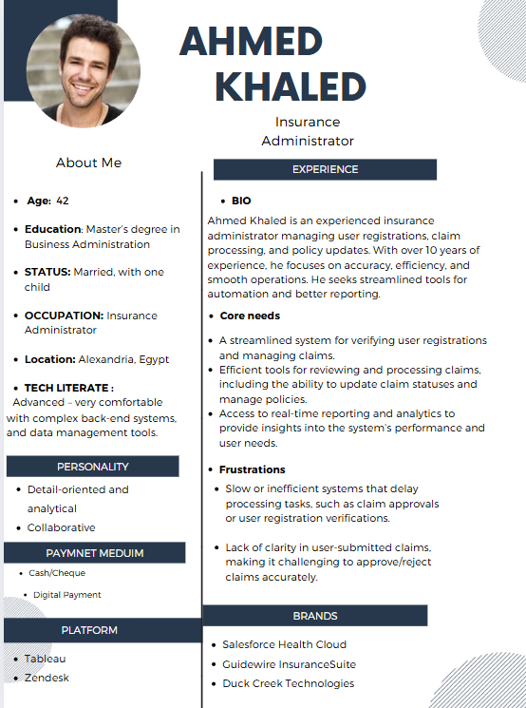

3-

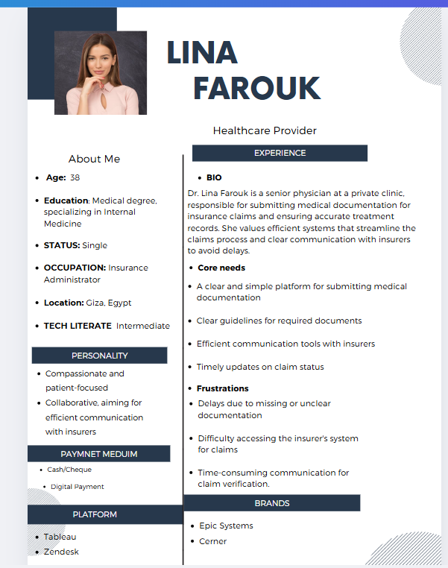

4-

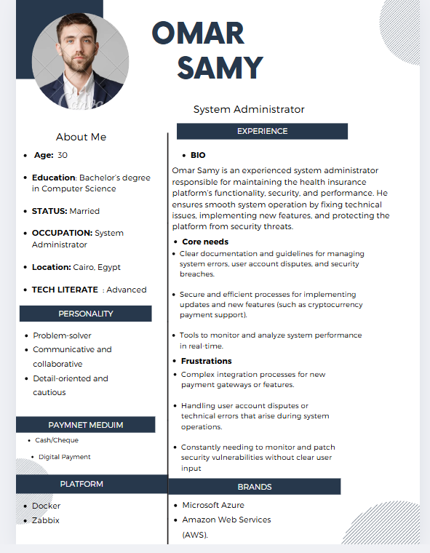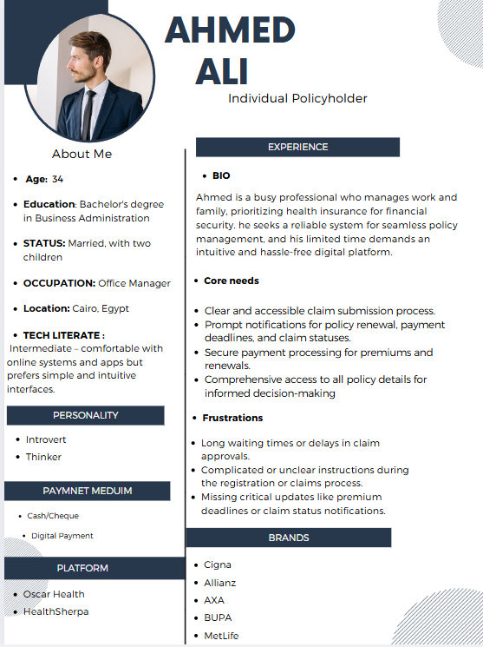

4- User stories :

| User Story 1: Register for Health Insurance | * As a patient, * want to register for health insurance by filling in my personal details and selecting a plan * so that I can obtain coverage for my medical needs. |
| --- | --- |
| User Story 2: Submit Health Insurance Claim | * **As a** patient * **I want** to submit a health insurance claim with treatment details and supporting documents * **so that** I can receive reimbursement for my medical expenses. |
| User Story 3: Pay Insurance Premium | * **As a** patient * **I want** to pay my insurance premium online using my preferred payment method * **so that** I can keep my health insurance policy active. |
| User Story 4: View Policy Details | * **As a** patient * **I want** to view the details of my health insurance policy * **so that** I can understand my coverage and exclusions. |
| User Story 5: Renew Health Insurance Policy | * **As a** patient * **I want** to renew my health insurance policy before it expires * **so that** I can maintain continuous coverage for my medical needs. |
| User Story 6: View Claim Status | * **As a** patient * **I want** to view the current status of my submitted health insurance claims * **so that** I can track the progress of my reimbursement. |
| User Story 7: Request Customer Support | * **As a** customer * **I want** to request customer support via the system * **so that** I can resolve any issues or get assistance with my health insurance. |
| User Story 8: Cancel Health Insurance Policy | * **As a** customer * **I want** to cancel my health insurance policy online * **so that** I can stop my coverage when it's no longer needed. |
| User Story 9: Update Personal Information | * **As a** patient * **I want** to update my personal information such as my address and contact number * **so that** my health insurance provider has my correct details. |
| User Story 10: Generate Policy Documents | * **As a** patient * **I want** to generate and download my health insurance policy documents * **so that** I can keep a copy for my records. |
| User Story 11: Request Policy Changes | * **As a** patient * **I want** to request changes to my health insurance policy, such as modifying coverage or updating beneficiaries * **so that** my policy reflects my current needs. |
| User Story 12: View Payment History | * **As a** patient * **I want** to view my past premium payments, * **so that** I can keep track of my payment history and receipts. |
| User Story 13: Feedback Submission | * **As a** patient * **I want** to submit feedback or suggestions about my health insurance experience * **so that** I can contribute to improving the service. |
| User Story 14: Manage Dependent Coverage | * **As a** patient * **I want** to add, remove, or update dependent information on my health insurance policy * **so that** I can ensure my dependents are properly covered. |
| User Story 15: Access Health Resources | * **As a** patient * **I want** to access health and wellness resources such as articles and tools * **so that** I can improve my knowledge and make informed decisions about my health. |
| User Story 16: Synchronize Patient Billing Records in Real-Time | * **As a** financial system user * **I want** to synchronize billing data in real-time after medical services are provided * **so that** patient billing records are always accurate and up-to-date. |
| User Story 17: Reconcile Pharmacy Charges | * **As a** financial system user * **I want** to reconcile pharmacy charges with patient bills * **so that** all medication costs are reflected accurately in the final invoice. |
| User Story 18: Manage Medical Staff Fees | * **As a** financial system user * **I want** to manage and track medical staff fees based on patient care * **so that** staff members are paid accurately and on time. |

5- sprints

**Sprints : User Stories to Include: Deliverables :**

| Sprint 1 (MVP Requirements) | **Register for Health Insurance**   * As a patient, I want to register for health insurance by filling in my personal details and selecting a plan so that I can obtain coverage for my medical needs.   **Submit Health Insurance Claim**   * As a patient, I want to submit a health insurance claim with treatment details and supporting documents so that I can receive reimbursement for my medical expenses.   **Pay Insurance Premium**   * As a patient, I want to pay my insurance premium online using my preferred payment method so that I can keep my health insurance policy active.   **View Policy Details**   * As a patient, I want to view the details of my health insurance policy so that I can understand my coverage and exclusions.   **View Claim Status**   * As a patient, I want to view the current status of my submitted health insurance claims so that I can track the progress of my reimbursement. | * Health insurance registration functionality. * Claim submission and document upload feature. * Online premium payment system with payment method selection. * Ability to view policy details and claim status. * Basic user login functionality and authentication. |
| --- | --- | --- |
| Sprint 2 (Additional Features and Refinements) | **Update Personal Information**   * + As a patient, I want to update my personal information such as my address and contact number so that my health insurance provider has my correct details.   **Request Policy Changes**   * + As a patient, I want to request changes to my health insurance policy, such as modifying coverage or updating beneficiaries, so that my policy reflects my current needs.   **Renew Health Insurance Policy**   * + As a patient, I want to renew my health insurance policy before it expires so that I can maintain continuous coverage for my medical needs.   **Request Customer Support**   * + As a customer, I want to request customer support via the system so that I can resolve any issues or get assistance with my health insurance.   **Generate Policy Documents**   * + As a patient, I want to generate and download my health insurance policy documents so that I can keep a copy for my records. | * Feature for updating personal details. * Request policy changes (coverage, beneficiaries). * Policy renewal functionality. * Customer support request feature. * Generate and download policy documents. |
| Sprint 3 (Enhancements, Reports, and Extra Features) | **View Payment History**   * As a patient, I want to view my past premium payments so that I can keep track of my payment history and receipts.   **Manage Dependent Coverage**   * As a patient, I want to add, remove, or update dependent information on my health insurance policy so that I can ensure my dependents are properly covered.   **Feedback Submission**   * As a patient, I want to submit feedback or suggestions about my health insurance experience so that I can contribute to improving the service.   **Access Health Resources**   * As a patient, I want to access health and wellness resources such as articles and tools so that I can improve my knowledge and make informed decisions about my health.   **Reconcile Pharmacy Charges**   * As a financial system user, I want to reconcile pharmacy charges with patient bills so that all medication costs are reflected accurately in the final invoice. | * Payment history and receipt viewing feature. * Management of dependent coverage. * Feedback submission feature. * Access to health resources (articles, videos, etc.). * Reconciliation of pharmacy charges with billing. |

6- use case Diagram :

